Name: Maloth Aditya
Roll No: 120CS0124

Question:
1. Set constant position for point-to-point nodes and as well as CSMA nodes.
2. Plot a graph by using Gnuplot via, .tr, considering throughput and goodput as parameters for your graph generation.
3. Display the result in NetAnim, Wireshark and TraceMetrics.

CODE:
/* -*- Mode:C++; c-file-style:"gnu"; indent-tabs-mode:nil; -*- */
/*
* This program is free software; you can redistribute it and/or modify
* it under the terms of the GNU General Public License version 2 as
* published by the Free Software Foundation;
*
* This program is distributed in the hope that it will be useful,
* but WITHOUT ANY WARRANTY; without even the implied warranty of
* MERCHANTABILITY or FITNESS FOR A PARTICULAR PURPOSE. See the
* GNU General Public License for more details.
*
* You should have received a copy of the GNU General Public License
* along with this program; if not, write to the Free Software
* Foundation, Inc., 59 Temple Place, Suite 330, Boston, MA 02111-1307 USA
*/

#include "ns3/core-module.h"
#include "ns3/point-to-point-module.h"
#include "ns3/network-module.h"
#include "ns3/applications-module.h"
#include "ns3/mobility-module.h"
#include "ns3/csma-module.h"
#include "ns3/internet-module.h"
#include "ns3/yans-wifi-helper.h"
#include "ns3/ssid.h"
#include "ns3/netanim-module.h"

// Default Network Topology
//
// Wifi 10.1.3.0
// AP
// * * * *
// | | | | 10.1.1.0
// n5 n6 n7 n0 -------------- n1 n2 n3 n4
// point-to-point | | | |
// ================
// LAN 10.1.2.0

using namespace ns3;

NS_LOG_COMPONENT_DEFINE ("ThirdScriptExample");

int
main (int argc, char *argv[])
{
bool verbose = true;
uint32_t nCsma = 3;
uint32_t nWifi = 3;
bool tracing = false;

CommandLine cmd (__FILE__);
cmd.AddValue ("nCsma", "Number of \"extra\" CSMA nodes/devices", nCsma);
cmd.AddValue ("nWifi", "Number of wifi STA devices", nWifi);
cmd.AddValue ("verbose", "Tell echo applications to log if true", verbose);
cmd.AddValue ("tracing", "Enable pcap tracing", tracing);

cmd.Parse (argc,argv);

// The underlying restriction of 18 is due to the grid position
// allocator's configuration; the grid layout will exceed the
// bounding box if more than 18 nodes are provided.
if (nWifi > 18)
{
std::cout << "nWifi should be 18 or less; otherwise grid layout exceeds the bounding box" << std::endl;
return 1;
}

if (verbose)
{
LogComponentEnable ("UdpEchoClientApplication", LOG_LEVEL_INFO);
LogComponentEnable ("UdpEchoServerApplication", LOG_LEVEL_INFO);
}

NodeContainer p2pNodes;
p2pNodes.Create (2);

PointToPointHelper pointToPoint;
pointToPoint.SetDeviceAttribute ("DataRate", StringValue ("5Mbps"));
pointToPoint.SetChannelAttribute ("Delay", StringValue ("2ms"));

NetDeviceContainer p2pDevices;
p2pDevices = pointToPoint.Install (p2pNodes);

NodeContainer csmaNodes;
csmaNodes.Add (p2pNodes.Get (1));
csmaNodes.Create (nCsma);

CsmaHelper csma;
csma.SetChannelAttribute ("DataRate", StringValue ("100Mbps"));
csma.SetChannelAttribute ("Delay", TimeValue (NanoSeconds (6560)));

NetDeviceContainer csmaDevices;
csmaDevices = csma.Install (csmaNodes);

NodeContainer wifiStaNodes;
wifiStaNodes.Create (nWifi);
NodeContainer wifiApNode = p2pNodes.Get (0);

YansWifiChannelHelper channel = YansWifiChannelHelper::Default ();
YansWifiPhyHelper phy;
phy.SetChannel (channel.Create ());

WifiHelper wifi;
wifi.SetRemoteStationManager ("ns3::AarfWifiManager");

WifiMacHelper mac;
Ssid ssid = Ssid ("ns-3-ssid");
mac.SetType ("ns3::StaWifiMac",
"Ssid", SsidValue (ssid),
"ActiveProbing", BooleanValue (false));

NetDeviceContainer staDevices;
staDevices = wifi.Install (phy, mac, wifiStaNodes);

mac.SetType ("ns3::ApWifiMac",
"Ssid", SsidValue (ssid));

NetDeviceContainer apDevices;
apDevices = wifi.Install (phy, mac, wifiApNode);

MobilityHelper mobility;

mobility.SetPositionAllocator ("ns3::GridPositionAllocator",
"MinX", DoubleValue (0.0),
"MinY", DoubleValue (0.0),
"DeltaX", DoubleValue (5.0),
"DeltaY", DoubleValue (10.0),
"GridWidth", UintegerValue (3),
"LayoutType", StringValue ("RowFirst"));

mobility.SetMobilityModel ("ns3::RandomWalk2dMobilityModel",
"Bounds", RectangleValue (Rectangle (-50, 50, -50, 50)));
mobility.Install (wifiStaNodes);

mobility.SetMobilityModel ("ns3::ConstantPositionMobilityModel");
mobility.Install (wifiApNode);

InternetStackHelper stack;
stack.Install (csmaNodes);
stack.Install (wifiApNode);
stack.Install (wifiStaNodes);

Ipv4AddressHelper address;

address.SetBase ("10.1.1.0", "255.255.255.0");
Ipv4InterfaceContainer p2pInterfaces;
p2pInterfaces = address.Assign (p2pDevices);

address.SetBase ("10.1.2.0", "255.255.255.0");
Ipv4InterfaceContainer csmaInterfaces;
csmaInterfaces = address.Assign (csmaDevices);

address.SetBase ("10.1.3.0", "255.255.255.0");
address.Assign (staDevices);
address.Assign (apDevices);

UdpEchoServerHelper echoServer (9);

ApplicationContainer serverApps = echoServer.Install (csmaNodes.Get (nCsma));
serverApps.Start (Seconds (1.0));
serverApps.Stop (Seconds (10.0));

UdpEchoClientHelper echoClient (csmaInterfaces.GetAddress (nCsma), 9);
echoClient.SetAttribute ("MaxPackets", UintegerValue (1));
echoClient.SetAttribute ("Interval", TimeValue (Seconds (1.0)));
echoClient.SetAttribute ("PacketSize", UintegerValue (1024));

ApplicationContainer clientApps =
echoClient.Install (wifiStaNodes.Get (nWifi - 1));
clientApps.Start (Seconds (2.0));
clientApps.Stop (Seconds (10.0));

Ipv4GlobalRoutingHelper::PopulateRoutingTables ();

Simulator::Stop (Seconds (10.0));

//Configure node positions
AnimationInterface anim("lab4.xml");
anim.SetConstantPosition(p2pNodes.Get(0), 12.0,12.0);
anim.SetConstantPosition(p2pNodes.Get(1), 24.0,12.0);
anim.SetConstantPosition(csmaNodes.Get(0), 24.0,24.0);
anim.SetConstantPosition(csmaNodes.Get(1), 12.0,24.0);
anim.SetConstantPosition(csmaNodes.Get(2), 12.0, 36.0);
anim.SetConstantPosition(csmaNodes.Get(3), 24.0,36.0);

AsciiTraceHelper ascii;
pointToPoint.EnableAsciiAll(ascii.CreateFileStream("lab4-point-to-point.tr"));
csma.EnableAsciiAll(ascii.CreateFileStream("lab4-csma.tr"));

csma.EnablePcapAll("lab4-pcap",false);

if (tracing)
{
phy.SetPcapDataLinkType (WifiPhyHelper::DLT_IEEE802_11_RADIO);
pointToPoint.EnablePcapAll ("third");
phy.EnablePcap ("third", apDevices.Get (0));
csma.EnablePcap ("third", csmaDevices.Get (0), true);
}

Simulator::Run ();
Simulator::Destroy ();
return 0;
}

OUTPUT:

NetAnim:
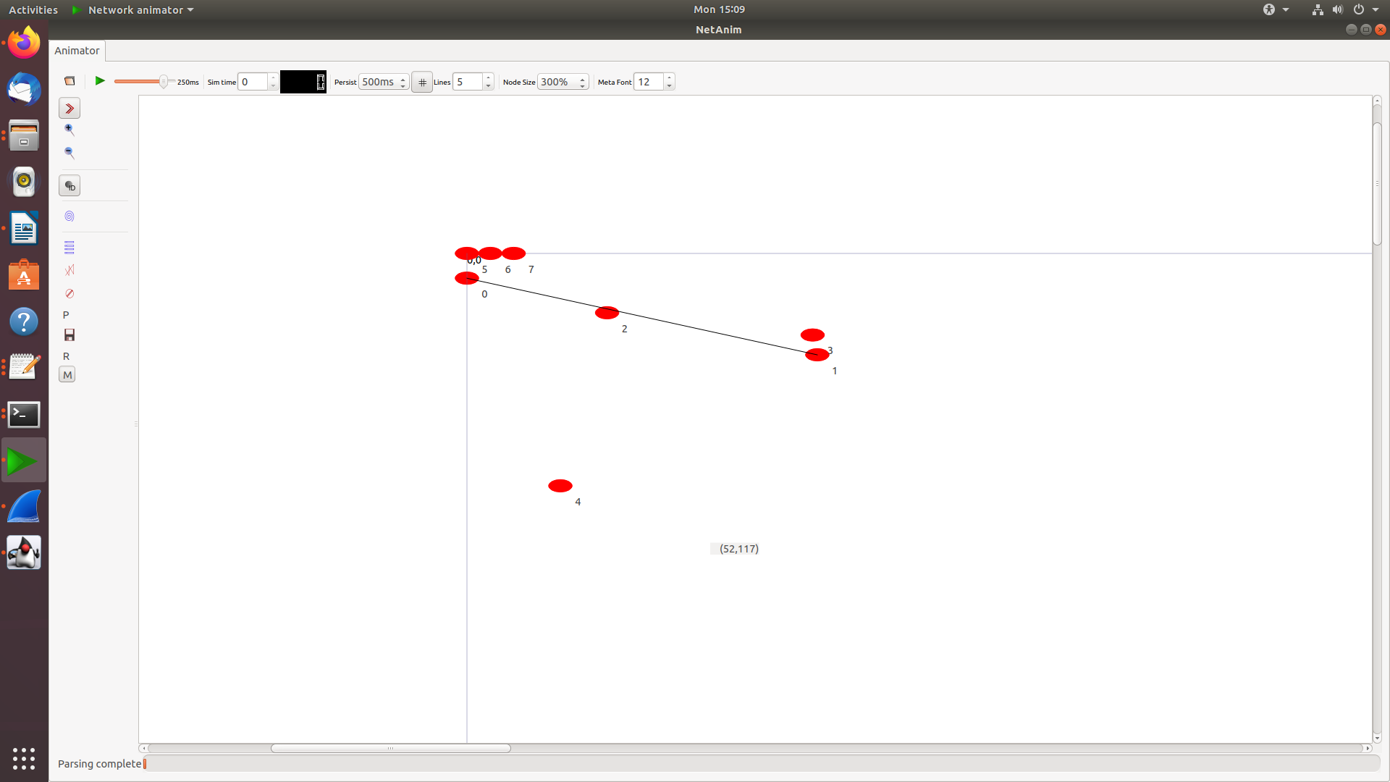
TraceMetrics:

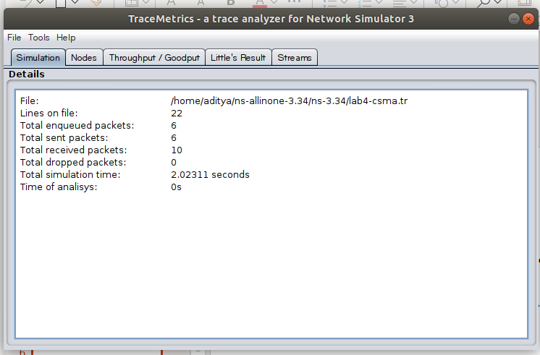
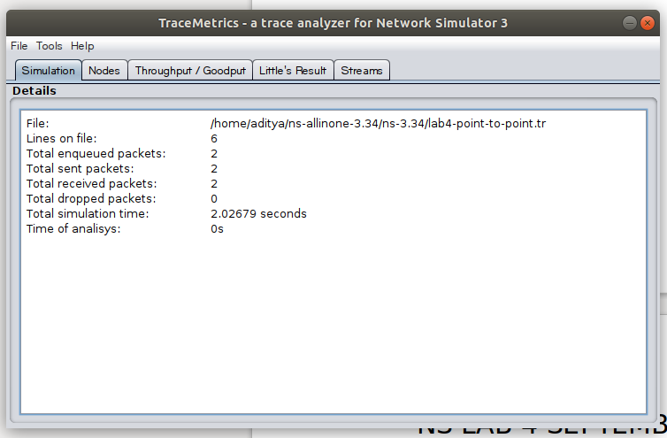
Wireshark:
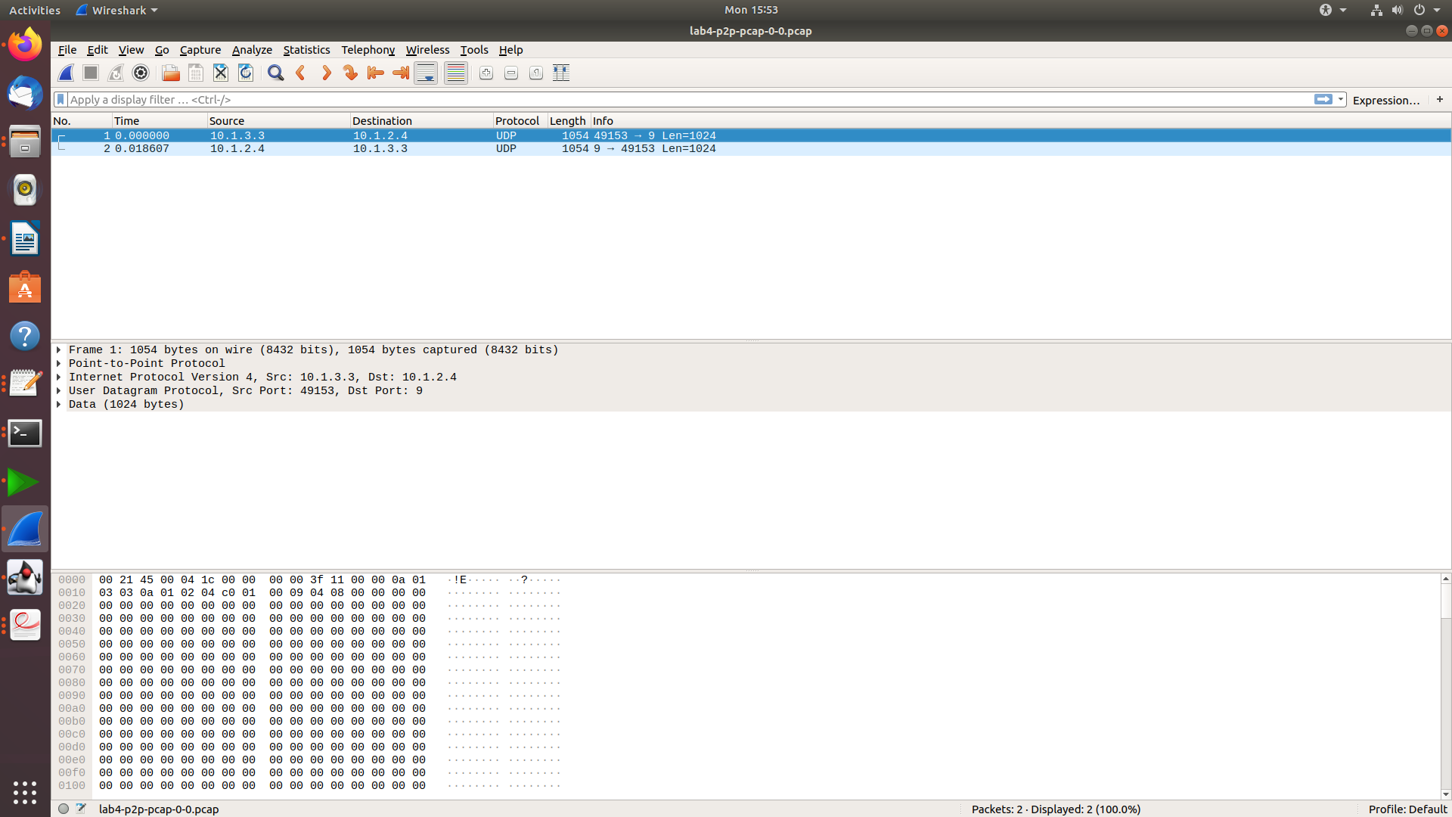
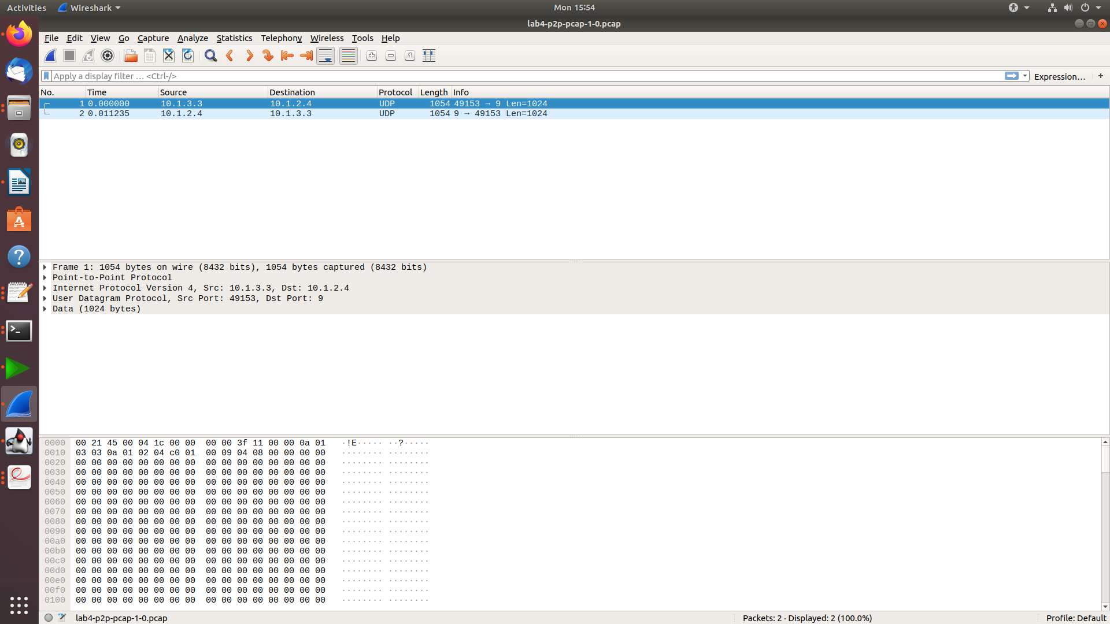
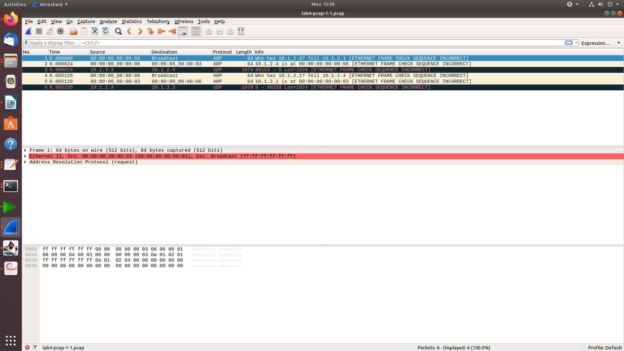
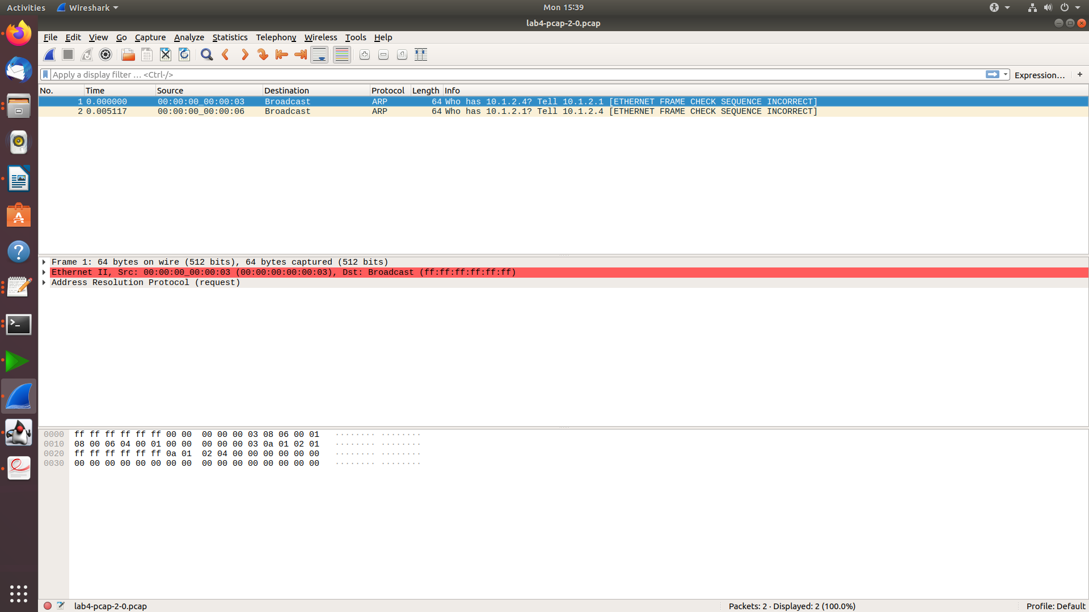
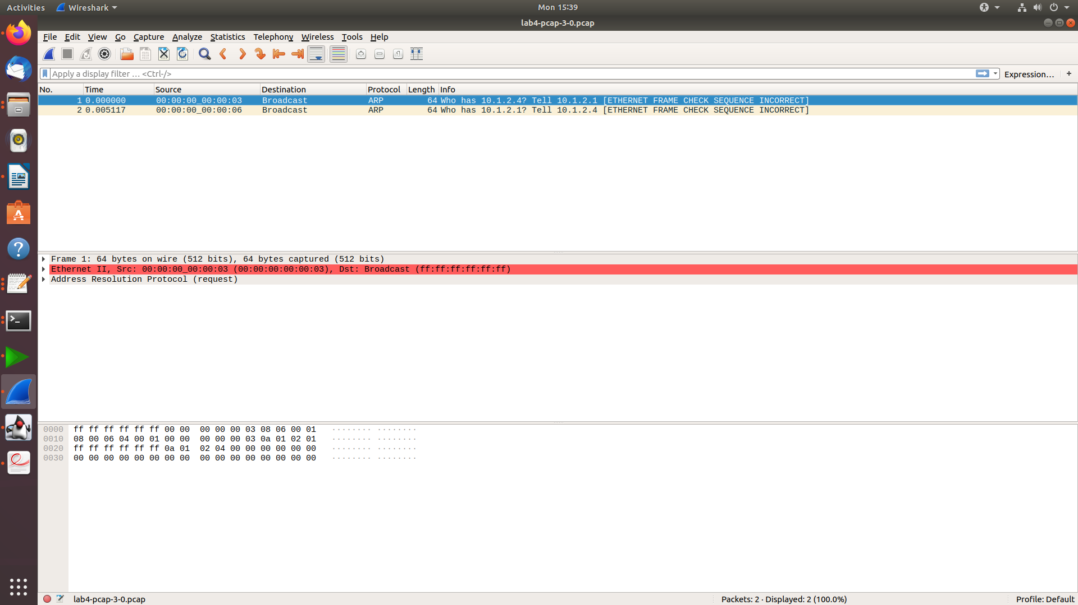
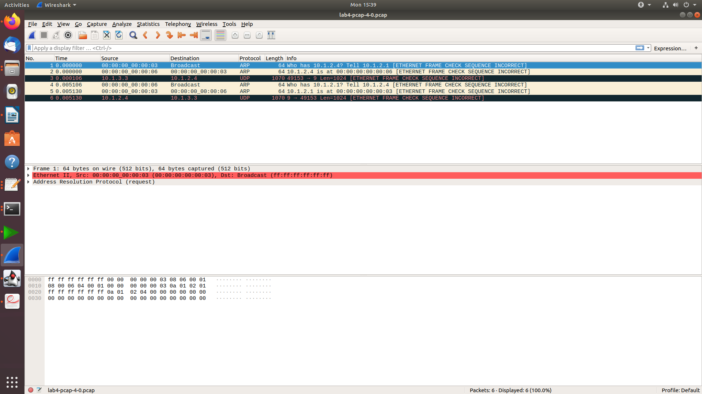
Gnuplot:
